Fragments of the updated text in the article are highlighted. Below is a table with comments from reviewers and comments by the authors.

Reviewer Note | Comment by authors | Page
You can delete figure 1 because it contains little useful information. | Comment accepted. Figure deleted
It is desirable to add one paragraph about the significance of the Sverdlovsk region for the Russian economy. | Comment accepted. Information added | p. 10
The conclusions should contain brief arguments of the author on why Russia was able to achieve great success in digitalization of VAT. | Comment accepted. Added conclusions on why Russia managed to achieve great success in digitalizing VAT. | p. 23
The reviewer suggests two ways to improve. The first one is to do more in.depth discussion without changing the narrative nature of this paper. If this approach is adopted, I recommend the title to be revised into “Digitalization of the VAT Administration in the Sverdlovsk region of Russia” so that the emphasis would be put on the administration aspects just as the author actually does in this paper. | Comment not accepted. According to the authors, the title “Experience in digitizing value added tax in the Sverdlovsk region of Russia” is more relevant for the topic of the article. | -
It is necessary, in the first place, to explain to the international readers why the question is of interest. | Comment accepted. Information added | p. 5
Some general criterions are needed to judge the digitalization of value added tax in this region. For example, the world best practices of the digitalization of VAT administration, some good practices, the experiences in other regions of Russia, et. al. Only with a referee, the readers can make a clear judgment on the progress this region made in the digitalization of the VAT administration. | Comment accepted. Added information about the countries of the European Union | p.12
To judge whether the digitalization of the VAT administration in the Sverdlovsk region is successful or not, it is more important to use related data and facts instead of listing the legislative process. | Comment accepted. Information added | p.18
When it comes to data, I recommend the author to pay attention to details. For example, the author did not explain why the number of enterprises decreased (Figure 4 and Figure 5) after the implementation of digitization. Does this have any relationship with the digitalization of the VAT administration? | Comment accepted. Information added | p. 17
The author pointed out existing problem in the digitalization process without making an in.depth analysis of its causes. | Comment not accepted. Analysis of the causes of the problem of digitizing VAT is not the purpose of this article | -
There are 2 fig. №6. Fig. 4, tab. 2, fig. 5, fig. 6 . no data source references (Figure 4. Number of enterprises and organizations in Russia; Table 2. Dynamics of VAT revenues to the federal budget in 2013.2018; Figure 5. Number of enterprises and organizations in the Sverdlovsk region; Figure 6. VAT receipts from the Sverdlovsk region to the consolidated budget of the Russian Federation)  Fig. 4, tab. 3, fig. 6 . no reference (Figure 2. Decomposition of VAT digitalization in Sverdlovsk region; Table 3. The main problems of VAT digitalization in Sverdlovsk region; Figure 6. Smart VAT model) | Comment accepted.

Experience of digitalization of value added tax in the Sverdlovsk region of Russia

Abstract: Currently, foreign and Russian researchers pay great attention to the implementation of digital technologies, both digitalization of taxation and digitalization of tax administration. The purpose of the study is to review the results of digitalization of value added tax (VAT) in the Sverdlovsk region. In this regard, the article reveals the general aspects of digitization of VAT and introduces its chronology in the region. The experience of digitizing the administration of VAT in the countries of the European Union is considered and the coefficient of VAT efficiency for a number of countries is calculated. In addition, a decomposition of the digitalization of value added tax was compiled and an extensive potential of digital tools used by the Federal Tax Service of Russia was shown. A comparative analysis of the results of VAT digitalization in Russia and the Sverdlovsk region is also presented. In order to compare the results of digitalization, the indicators of VAT efficiency (C-efficiency) and its collection are estimated. An analysis of statistics was carried out regarding the number of legal entities - payers of value added tax, with justification of the reasons for the decrease in the number of taxpayers. Further, the article highlights the problems of VAT digitalization, the main of which is the taxpayer’s reluctance to join the digital environment. The authors consider a promising scenario for the development of VAT in the framework of the digitalization of the economy and characterize the transformation vector as directed towards the formation of a “smart value added tax”. This is a model of the future universal indirect tax, calculated and levied without human intervention and based on the use of blockchain technology. In conclusion, the authors consider the reasons for the success of VAT digitalization in Russia and the Sverdlovsk region, and also present prospects for the digital VAT development, in particular, the transition to intellectual tax.

Key words: value added tax; digital value added tax; the regional aspect of digitalization; automated control system of value added tax, C-efficiency.

1 Introduction

The digital revolution generates tremendous changes in the social, economic and political spheres, since the Internet, social media, big data and automation are fundamentally changing the way people live (Bloch & Bacache-Beauvallet, 2017). Tax systems are an integral part of this change, and many countries are experiencing a steady movement towards the introduction of electronic technologies in the daily interaction of tax authorities and taxpayers (Crémer, 2015).
Digital technologies are attractive to government agencies for many reasons (PwC, 2010). For example, they can provide the tax authorities with a more detailed picture of the taxpayer’s status and thus help reduce the tax gap. Also, they assist in reducing the administrative burden on the tax authority and, if implemented properly, on the taxpayers as well.
In addition, such innovations not only improve efficiency, but also transform the existing taxes and the taxation as a whole: for example, pre-filling of tax returns for citizens, practiced in the countries of the European Union (ICAEW, 2019), fundamentally changes the situation with tax compliance, moving toward a paradigm in which the government automatically prepares the tax returns, and the citizens are responsible for their audit (McKinsey Global Institute, 2016). Obviously, such tax returns disregard tax planning and may not always apply the most tax-optimal regime in relation to individual citizens, but facilitate the individual submission of tax returns.
Despite the fact that digitalization of a number of procedures can provide a significant reduction in the cost of tax administration, there are certain optimal approaches to the process of implementing digital innovations that should be taken into account, as well as common mistakes that should be kept in mind (Deloitte, 2015). For instance, testing through pilot studies and step-by-step implementation of new software will reduce the complexity of the transition to digital administration. On the other hand, if the mandatory transition to new digital methods happens too fast, it will result in additional costs for taxpayers (Pritchard, et al., 2017).
Apart from practical aspects, implementation of new technologies leads to changes in the concept of taxing, in particular, collection of the value added tax (VAT). The existing theoretical models were developed in the age of printing regardless of fundamentally new phenomena such as electronic services, electronic payments, virtual data, and so on (EY., 2015). The format of business processes is changing so rapidly that once developed theoretical models become inevitably obsolete even before their full-scale practical testing. In the circumstances, public authorities find it quite difficult to develop regulatory documents, and the theorists of economic science consider the interpretation of the digital revolution as a complicated task.
However, classifying the general theoretical and practical issues as more specific and considering issues in terms of only one object will contribute to the promotion of theoretical knowledge in the sphere of taxation.
The digitalization of VAT administration and the digitalization of the tax itself are not only global trends, but also their regional manifestation. The smooth functioning of the system in the field is manifested in improving the quality of VAT administration in general. The purpose of this study is to review the mechanisms of digital VAT processing and digitalization of VAT administration in the Sverdlovsk region. First of all, general issues of digitization will be considered, and then a decomposition of tax digitalization in the Sverdlovsk region will be presented. To confirm the effectiveness of digitalization, the efficiency factor of VAT administration in Russia and the VAT collection rate in Russia and the Sverdlovsk region will be calculated.

2 Review of existing studies

The digitalization processes and, in particular, the digitalization of the economy are considered in domestic and foreign sources both in the scientific and business environment. From the theoretical point, an attempt is made to identify the solid foundation of the IT revolution, while the business circles are in search of the most profitable areas for the implementation of digital solutions.
The English research works introduced the notable report by the Institute of Chartered Accountants of England and Wales "Digitalization of tax: international perspectives" (ICAEW, 2019), considering the objectives, opportunities, challenges of digitization, and also presenting an overview of the experience of Russia and other countries. Christina Trenta, professor of the Tax Law department at the University of Örebro (Sweden), explored the European VAT in the era of digitalization, and her work is interesting in terms of examining the European experience in introducing new technologies (Trenta, 2018). An international research group issued a guide to VAT of electronic services, which describes the useful experience of digitalization of VAT in the EU (Bird Advokat KB, 2014). Also, of some interest is the research conducted by the major consulting companies (PwC, 2016) and experts from the OECD (OECD, 2016).
The Russian sources provide quite informative reviews and reports of consulting companies (Grachev, 2016), tax experts, analysts of the analytical information portals (in particular, Garant and Consultant), as well as representatives of the research community. Both general and more specific aspects are considered. Thus, V. Vishnevsky and V. Chekina describe the fourth industrial revolution in terms of taxation and assess the prospects for the development of tax instruments in the new conditions (Vishnevsky & Chekina , 2018). S. Kniaziev considers digital technologies as a tool for the implementation of the state policy (Kniaziev, 2017). I. Mayburov and A. Kireenko examine the stages of tax reforms in modern Russia (Mayburov & Kireenko, 2018). It should be noted that the concept of electronic VAT administration was also considered (for example, Charlet, A., and J. Owens) (Charlet & Owens, 2010). In addition, Pomeranz points to the need to use information technologies in VAT administration (Pomeranz, 2015). The experience of implementing new digital laws is analyzed in the business journals.
The level of cities and regions is most often considered by practitioners. Here we can highlight A. Bryzgalin, Yu. Truntsovsky, V. Zudin Also noteworthy are the reports of the companies PWC, TaxCom, Bryan Cave Leighton Paisner (Russia) LLP. It should be noted that digital taxation is often considered in the context of Smart Cities systems.
It can be generally concluded that the issues of digitalization are widely covered in both foreign and Russian sources, thus allowing for a more detailed consideration of the VAT transformation.

3 Digitization of VAT against the background of digitization of taxation

The most simplified definition can be represented by a formula: digitalization = change, and with it there is a change both at the qualitative and quantitative levels. When considering digitalization of various objects, there are more detailed definitions that take into account the specific scope of implementation (Mayburov, 2015). It should be noted that digitalization is quite a flexible phenomenon, and in each new case the implementation of digital technologies adapts to the requirements of the participants in the process.
In the Sverdlovsk region, as well as throughout Russia, digitalization at the legislative level was first introduced in 2017 by the national program “Digital Economy”. However, the elements of introduction of new technologies in the economy were observed long before the official announcement. In the framework of the program there emerged such orientation as "digital taxation", digital VAT in particular. This term is not official, but can be used, since VAT has been the leader among Russian taxes in terms of digitalization. This situation is due to the following reasons:
- VAT is the most significant fiscal tool in Russia.
- VAT digitalization affects a wide range of participants: taxpayers (individuals and legal entities), the state, and software developers.
- The digitalization contributes to reducing the extent of VAT evasion.
In the Sverdlovsk region the main digital transformations in relation to VAT are:
– Transition to remote interaction between taxpayers and tax authorities. The information exchange is carried out by means of specialized software and allows for almost complete cancellation of the printed form of documents.
– Implementation of digital tools in the activities of both taxpayers and tax authorities (personal account of the taxpayer, VAT, etc.).
Preparation for VAT digitization was launched in 2010. First of all, the legislative framework was worked out, which allowed the launching of intensive adoption of automated control systems at the end of 2013. The tax legislation to date is being improved.
As is known, the basic document in the VAT sphere is the Tax Code of the Russian Federation (TC RF), but this document ignores many of the new circumstances in the economic sphere, which makes it outdated and largely irrelevant (Leontyeva & Mayburov , 2016). Thus, despite the large-scale penetration of Internet technologies into the social life, the tax code lacked provisions regarding electronic services, and this was especially manifested as a loss of amounts of value added tax. In order to correct the current situation, a number of legislative amendments were made to the tax code. Thus, as of January 1, 2019, the place of sale of goods, works and services is the territory of the Russian Federation if the terms are complied with article 147 and article 148 of the Tax Code of the Russian Federation (TC RF). In 2016, the TC RF introduced for foreign legal entities article 174.2, which regulates the peculiarities of interaction with the tax authorities of Russia, in particular, obliges foreign companies, operating in the territory of the Russian Federation, to register with the tax authority. It should also be noted that since 2017 the so-called "Google tax" has been in force, which regulates the mechanism of VAT payment by non-resident companies selling services in the territory of the Russian Federation.
The chronology of the digital transformation of VAT on the regional level can be presented as follows (table 1).

Table 1. Chronology of VAT digitalization on the regional level
Stages | Events
II Sta  ACS V  I Stage  A  CSVAT  g  e  A  T 2  А  IS  Tax -3 | 01.10.2013 – launching of implementation of Automated control system of value added tax (ACS VAT) in territorial divisions of the Federal Tax Service. 2014 – mandatory VAT declaration in electronic form.  2015 – extended electronic declaration with the inclusion of information about all transactions in the VAT declaration.  01.04.2015 – transition to ACS VAT-2 that operates on the basis of "Big Data"  01.07.2017 – special control and analytical departments have been created in the structure of territorial tax authorities to work with illegal tax optimization schemes  2019 - the Tax-3 Analytical Information System (AIS Tax-3) is introduced. This system represents is a unified information system of the tax authorities of Russia. This system will automate the activities of tax authorities for all functions performed

As for the processes accompanying the above stages in the Sverdlovsk region, in general they can be presented as follows (figure 1)

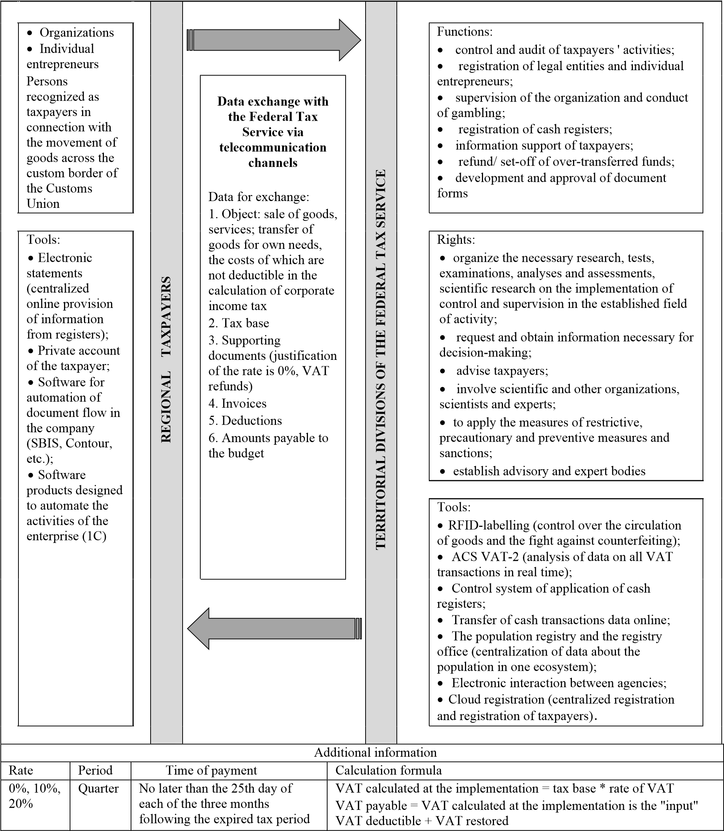
Figure 1. Decomposition of VAT digitalization in the Sverdlovsk region

In 2018, the Sverdlovsk region entered the top 40 regions in terms of digitalization and took 37th place (Kostyleva, 2018). This position indicates a lack of use of digital tools both in general in the activities of various ministries and departments of the region and in particular in the activities of the Federal Tax Service.
In the future, the Federal Tax Service plans to create a global regional network of voluntary compliance with tax legislation, which will fully automate the calculation of tax liabilities and tax payments. It will also be possible to administer taxes in real time. In addition, it is planned to expand the list of services for taxpayers, which will minimize the number of tax evasion (Koroleva, 2018). As a result, the obligation to file tax returns will become irrelevant and will be removed from taxpayers. Thus, conditions will be created for the most comfortable activity of bona fide VAT payers and at the same time, the possibilities for the functioning of tax evasion schemes will be minimized.
Figure 2 represents the general level of penetration of digital technologies in the activities of Federal Tax Service in Sverdlovsk region, particularly in respect of VAT. However, the digital tools used today should be considered in more detail, since they have no analogues in the world, and the system of ACS VAT is widely regarded as unique.
The Sverdlovsk region is the largest industrial region in Russia with well developed chemical, forestry, woodworking, and food industries (Arkhipova, Kulikova, & Ilina, 2019). The concentration of production in the region is four times higher than the national average. The region is among 13 non-subsidized regions of the country. According to the typology of regions developed by the Institute of Independent Social Policy, the Sverdlovsk region belongs to relatively developed regions, ceding the leading role to Moscow, St. Petersburg, the Khanty-Mansiysk, Yamalo-Nenets and Nenets Autonomous Districts, and the Sakhalin Region (Violin, 2018).

4 Automated control system of value added tax (version 2)

The Automated control system of value-added tax (ACS VAT) is an unparalleled tool for tracking VAT-taxable transactions. The system is not just woven into the web of new digital tools of the Federal Tax Service, but it is also a key element (Davletshin, 2017). Since 2015, Sverdlovsk region has been implementing an updated version of the Automated control system – ACS VAT 2 (Rukina, 2017). The system enables real-time monitoring of value creation and comparing of tax returns in a cross-format, as well as automatically determining the risk profile of the taxpayer (figure 2).
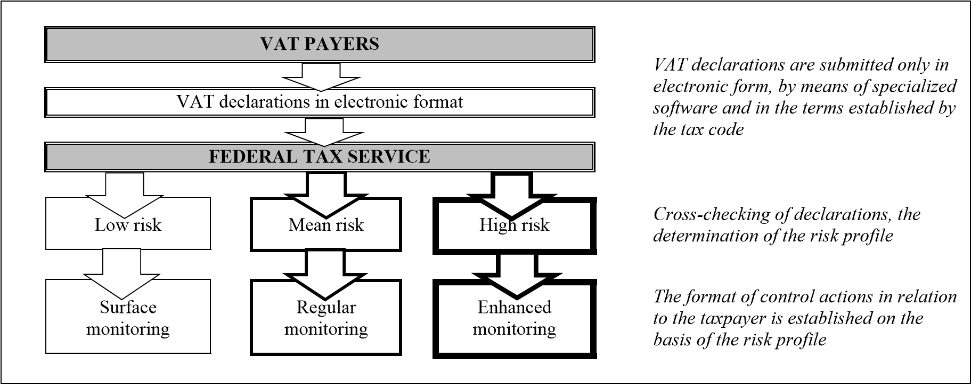
Figure 2. Automated control system of value added tax (version 2)

Operation of ACS VAT 2 is based on the strategy of the risk-based approach, in other words, its core is the risk management system. The scope of risk management system includes the operations for reimbursement and payment of tax, and the risk analysis addresses the operations of the taxpayers (previously only the indicators of their activities were evaluated). All transactions are divided into three categories: low risk, mean risk and high risk. It is worth noting that the categorization is carried out with the integrated use of four methods of risk analysis: "traffic light", "gap detection", "tree of connections" and "narrowing of the ring".
More than 80 risk criteria are also applied. For taxpayers of the "green" zone (low risk), the most comfortable conditions for business conduct are created and services for informing and consulting are provided by the Federal Tax Service (Karpova & Mayburov, 2018). Identification with the "yellow" zone activates the tax inspector’s work in preventing violations. In addition, the nuances of the current legislation are explained, and the opportunity to correct mistakes is provided. Also worth noting is the fact that interaction takes place in a remote format through specialized software. The most dangerous is the assignment of the operation to the "red" zone. In this case, tax audit is appointed on-site, which will be followed by the enhanced control of the Federal Tax Service.
This approach, on the one hand, enables minimization of the possibility of tax evasion schemes and schemes of unjustified VAT refund, and on the other hand, it facilitates identification of the existing schemes, including the involvement of a large number of participants and operations.
According to the Federal Tax Service, only 10% of the "green" firms are denied VAT refunds, while among the "red" taxpayers this figure exceeds 60% (Pyshkina & Yakushev , 2018).

5 Digitalization experience of VAT administration

Digital technologies are actively used by governments of many countries to optimize the activities of ministries and departments. Digitalization is especially important for tax services, since the introduction of tools for uninterrupted control over the activities of taxpayers opens up large-scale fiscal and regulatory prospects. According to a study by Ernst & Young, most tax authorities begin the digitalization specifically with VAT (EY, 2017). The reason is the highly transactional data accompanying the taxable operation.
In Russia, the VAT model is built in the image and likeness of the European Union. Given the current situation with the introduction of digital VAT administration in the EU, we can note that in the EU VAT was also the first tax in the digital taxation system. In 2005, the Organization for Economic Co-operation and Development (OECD) created the universal electronic format SAF-T, which companies in any of the 38 participating countries can use to submit VAT reports. This is a scheme for the exchange of information between tax authorities and companies, which can be applied consistently in all “connected” countries. So, France, Luxembourg, Austria, Poland, Portugal, and Lithuania were the first to introduce this system (Mróz, 2019).
According to the Institute of Certified Accountants (ICAEW, 2020), today the main digital forms of VAT reporting in the EU are:
- Control Statements: Mandatory e-books of sales invoices with detailed VAT calculations submitted with a regular VAT return. As a rule, they are intended only for domestic sales and supplement the list of sales in the EU.
- SAF-T: Mandatory lists of XML-based sales, purchases, stocks, fixed assets and banking transactions.
- Live invoice reporting: real-time information about sales invoices is received by the tax office, often with reverse electronic approvals.
Nevertheless, a number of states (Netherlands, Belgium, Italy, Spain) have developed and introduced their own formats for submitting VAT reports in electronic form, which significantly complicates the procedure for monitoring the activities of taxpayers (Avalara, 2020).
The indicator C-efficiency (coefficient of efficiency) is widely used to assess the quality of tax administration in the world practice. The closer the coefficient is to 1, the higher the quality of tax administration in the country. The formula for calculating the coefficient is as follows:

$C-efficiency=\frac{VAT Revenue}{Standard VAT Rate × Final Consumption Costs} .$ (1)

Data for some EU countries are presented in table 2.

Table 2 – Administration of value added tax in the EU countries (2018)
Country | Reporting format | Basis | Final  consumption, mln euro | VAT rate, % | VAT revenue,  mln euro | C-efficiency
Luxembourg | SAF-T | On request | 19 997. 2 | 17% | 3 729. 5 | 1.00
Norway | SAF-T | Not yet implemented | 143 578. 5 | 25% | 30 92. 8 | 0.86
Czech Republic | Control statement | Mandatory with VAT return | 100 515. 2 | 21% | 15 929. 3 | 0.75
Austria | SAF-T | On request | 199 724. 0 | 20% | 29 323. 4 | 0.73
Hungary | Real-time invoice reporting | Mandatory, live for all invoices  above HUF 100k | 66 293. 6 | 27% | 12 949. 7 | 0.72
France | SAF-T | On request | 1 237 192.0 | 20% | 168 902. 0 | 0.68
Latvia | Control statement | Mandatory with VAT return | 17 115. 7 | 21% | 2 449.1 | 0.68
Poland | SAF-T | Mandatory with VAT return | 286 419. 1 | 23% | 40 410, 7 | 0.61
Lithuania | SAF-T | On request | 27 939.7 | 21% | 3 522. 2 | 0.60
United Kingdom | MTD (Making Tax Digital) | Mandatory quarterly VAT return  data only - no transaction  reporting | 1 515 655. 9 | 20% | 168 688. 0 | 0.56
Portugal | SAF-T | Mandatory for residents with VAT  return | 140 301.1 | 23% | 17 865. 4 | 0.55
Romania | Form 394 | Mandatory with VAT return | 125 846.4 | 19% | 12 889. 9 | 0.54
Spain | SII (Immediate Information  Supply) | Mandatory for large tax payers  every 4 days | 727 489.0 | 21% | 79 264.0 | 0.52
Greece | Live invoice reporting | Mandatory on all invoices | 133 843.4 | 24% | 15 288. 0 | 0.48
Italy | SdI - Sistema di Interscambio | Mandatory live invoice reporting  for all businesses | 1 077 202. 8 | 22% | 109 362. 0 | 0.46

The table shows that the highest quality of tax administration is typical for countries with standardized reporting forms for VAT .

6 Results of introducing ACS VAT

Federal level
According to the Federal Tax Service, 2018 set a record for tax collection, showing an increase of more than 20%. High-quality tax administration has one of the leading roles to play in that regard.
As for VAT revenues to the consolidated budget of the Russian Federation, in 2018, the increase was 16.4%. Such dynamics is observed against the background of the reduction in the total number of enterprises and organizations in the Russian Federation (figure 2). The chart uses data from the Russian State Statistics Service for the period 2005-2017.

4300000
4400000
4500000
4600000
4700000
4800000
4900000
5000000
5100000
2005
2010
2012
2013
2014
2015
2016
2017
2011
Figure 2. Number of enterprises and organizations in Russia

Also, since 2013, the indicators of accrued and paid tax amounts have increased. However, the percentage of tax arrears have remained at 3-5 per cent (table 3). To compile the table, data from the Russian State Statistics Service for the period 2013-2018 were used.

Table 3. Dynamics of VAT revenues to the federal budget in 2013-2018, billion rubles
Year | 2013 | 2015 | 2018
VAT on goods (works, services) sold in Russia
Accrued | 5 940 | 7 084 | 9 046
Paid | 5 628 | 6 711 | 8 450
Debt | -312 | -373 | -596
Collection rate | 95% | 95% | 93%
VAT on goods imported into Russia
Accrued | 419.34 | 580.68 | 700.31
Paid | 411.86 | 580.52 | 701.07
Debt | -7.48 | -0.16 | 0.76
Collection rate | 98.22% | 99.97% | 100.11%

Especially effective is the administration in relation to imported goods is particularly effective, since the tax collection is almost at 100%.
To assess the results of the implementation of the ASK VAT-2 system, we calculate the value of the efficiency coefficient by the formula (1), using the data of the Russian State Statistics Service for the period 2010-2018. The value of the coefficient will be determined by two indicators: VAT on goods, works and services sold in the territory of the Russian Federation (RF) and on total revenues from VAT to the consolidated budget of the Russian Federation, taking into account import operations. The calculation of this indicator is given in table 4.
Table 4. Dynamics of the coefficient of effectiveness of value added tax
Indicators | Year
 | 2010 | 2012 | 2014 | 2016 | 2018
VAT receipts for goods (works, services) sold in the territory of RF, billion rubles | 1329.1 | 1886.4 | 2188.8 | 2657.7 | 3574.8
VAT receipts for goods imported into the territory of RF, billion rubles | 1169.5 | 1659.7 | 1751.4 | 1913.7 | 2442.2
Total VAT revenues, billion rubles | 2498.6 | 3546.1 | 3940.2 | 4571.4 | 6017
Final consumption costs, billion rubles | 3214.,8 | 4247.5 | 56510.7 | 61389.8 | 6933.0
Base VAT rate, % | 18% | 18% | 18% | 18% | 18%
C-efficiency for VAT on goods (works, services) sold in the territory of RF | 0.23 | 0.25 | 0.22 | 0.24 | 0.29
C-efficiency for VAT total | 0.43 | 0.46 | 0.39 | 0.41 | 0.48

The table shows that, despite the introduction of digital systems, the effectiveness of VAT administration in Russia remains much lower than in European countries. This may be due to insufficient adjustment of the implemented system. Therefore, a more detailed study of the mechanism of electronic interaction between the tax service and the taxpayer is required.

Regional level
Despite the fact that VAT is a federal tax, its collection depends on the work of the tax authorities "on the ground", that is, in the regions (Sergi, 2018). The Sverdlovsk region can be considered an illustrative example of the impact of digital transformations in the VAT administration on the indicators of tax collection.
First of all, in this context it should be noted that the region has also been witnessing a decrease in the number of enterprises and organizations for 6 years (figure 4). The chart uses data from the Russian State Statistics Service for the period 2005-2017.

0
50000
100000
150000
200000
250000
2005
2010
2011
2013
2014
2015
2016
2017
2012
Figure 4. Number of enterprises and organizations in the Sverdlovsk region

The general tendency both for Russia and the Sverdlovsk region in particular is the decrease in the number of companies and individual entrepreneurs after the introduction of the ASK VAT-2 system. According to the Federal Tax Service of Russia, the reduction is justified by a decrease in the number of companies with signs of fictitiousness. These companies are also called “short-lived firms”. A short-lived company is a legal entity that does not have actual independence, was created without the goal of doing business and, as a rule, not presenting tax reporting. In 2011, the number of such companies was 40.1% (1.8 million) of the total number of registered legal entities, in 2016 - 1.6 million, in 2017 - 1.2 million, as of January 1, 2018 - 528.2 thousand, and as of June 1, 2018, the number of one-day firms was 309.5 thousand (7.3% of the total number of registered legal entities) (Kopalkina, 2020).
However, tax revenues show a positive trend (figure 5). The chart uses data from the Office of the Federal State Statistics Service for the Sverdlovsk Region.

-20,000,000
0
20,000,000
40,000,000
60,000,000
80,000,000
100,000,000
120,000,000
2013
2015
2018
Accrued
Paid
Debt

Figure 5. VAT receipts from the Sverdlovsk region to the consolidated budget of the Russian Federation, thousand rubles

In 2015, when the modified system of VAT 2 was introduced, there was an increase in the debt indicator (Tsykura, 2017). However, the rate dropped significantly in 2018. Such dynamics is related to the technical issues of implementation and debugging of VAT 2.
Also during the period of 2013-2015, the number of on-site VAT audits was reduced from 1285 to 806, and the number of desk audits - from 301 370 to 279 592. By the end of 2018, the total number of on-site inspections had amounted to 1058, which indicates the sufficiency of the remote control implemented through automated systems.
In order to evaluate the effectiveness of digitalization of VAT administration in the Sverdlovsk region, we consider such an indicator as the tax collection rate. This is the ratio of the amount of actually received VAT to the amount of tax debt. To calculate the efficiency coefficient of VAT, we will use the open data forms of statistical tax reporting of the Federal Tax Service of Russia. The calculation is shown in table 5.

Table 5 - Calculation of the efficiency coefficient of VAT in the Sverdlovsk region
Indicators | Year
 | 2010 | 2012 | 2014 | 2016 | 2018
Russian Federation (RF)
Accrued for VAT on goods (works, services) sold in RF, billion rubles | 1 421.54 | 1 996.63 | 2 285.67 | 2 843.78 | 3 698.17
Received in the budget, billion rubles | 1329.1 | 1886.4 | 2188.8 | 2657.7 | 3574.8
Collection rate, % | 93% | 94% | 96% | 93% | 97%
Sverdlovsk Region
Accrued for VAT on goods (works, services) sold in the territory of RF, billion rubles | 39.13 | 48.66 | 55.28 | 68.22 | 83.59
Received in the budget, billion rubles | 35.60 | 46.37 | 52.31 | 65.47 | 81.10
Collection rate, % | 91% | 95% | 95% | 96% | 97%

The collection rate of VAT in the Sverdlovsk region shows a stable positive trend in the period 2010-2018. A similar indicator for Russia is less stable. This confirms the improvement in the quality of VAT administration in the region.

7 Problems of VAT digitalization in Sverdlovsk region

Despite the large-scale and rapid digitalization of VAT, there are also a number of problems which often slow down the ongoing reforms. The following main obstacles arising at the stage of VAT digitalization can be distinguished (Table 6).

Table 6. The main problems of VAT digitalization in Sverdlovsk region
Problem | Characteristics of the problem | Possible solutions
Digital detachment | The most common problem is manifested either in the reluctance of users to move to a new format of interaction with the tax authority, or in the lack of stable access to channels of information and communication interaction (for example, the lack of the Internet, reluctance to purchase expensive software). | Introduction of liability for noncompliance with the new reporting format; organization of Internet access points in remote areas of the region.
Cost and | The introduction of new software is costly for both | The costs of the tax authorities are
complexity | tax authorities and taxpayers. The number of specialists who are familiar with new programs is limited. | compensated by increased collection of taxes, and avoidance of possible fines offsets the costs of taxpayers. Training seminars for employees should also be conducted.
Security & privacy | Electronic communications are open to many potential abuses, and there is a human factor. | Implementation of multi-stage control over the activities of data operators; improvement of the protection of user’s data.
Data transition | Previous reporting is stored in hard copy or in unadapted format. There is a need for additional information. | Conversion of the most important documents into a new format.
Legislative inconsistencies | The existing regulatory system was developed during the non-digital taxation period and disregards the current situations. | Adjustment of the existing legislation; development and adoption of new bills.

Thus, efficient digitalization of taxes, including VAT, is only possible in case of coordinated interaction of tax authorities, taxpayers and software designers. In addition, adequate legal support for digitization should be provided (Sergi, Berezin, Gorodnova, & Andronova, 2019).

8 Prospects for digital VAT

Further development of digital technologies and improvement of the existing format of interaction between VAT payers and the Federal Tax Service should inevitably lead to the transition from traditional VAT to a new qualitative level – smart VAT (Protopopova, 2014).
Smart VAT (smart-VAT) is a model of the future universal indirect tax, calculated and collected without human intervention. It is based on blockchain technology (Fig. 6) (EY, 2016). The first step in this direction has been made in 2018, with the introduction of online cash desks.

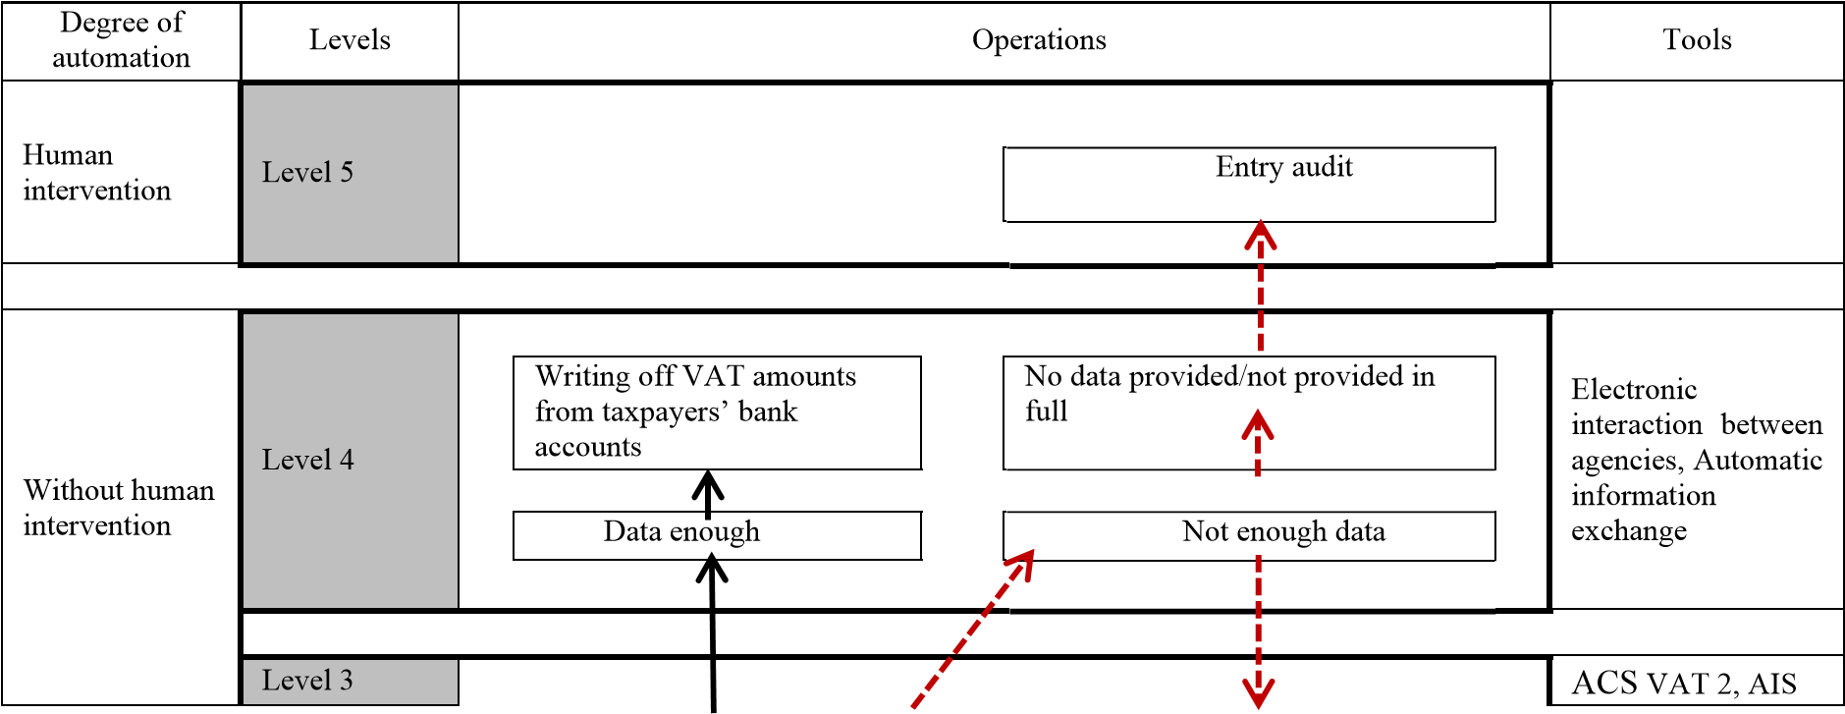
In-house audit of taxpayers
based on collected data
Submitting a request for data to the
taxpayer
tax-3

Level 2

Collection of information on all taxable transactions
Control system of
application of cash
registers, Transfer
of cash transactions
data online, smart
contracts, Big data,
RFID-
identification,
Cloud registration

VAT payers and many taxable transactions
Level 1
Figure 6. Smart VAT model

The new model will provide a level of automation that allows of online estimating and writing off tax amounts from the taxpayer's account (Brattsev & Roybu, 2018). As a result, the need to submit tax returns will be cancelled, and the inspector's intervention is restricted to exceptional cases (Ismagilov, 2019). It is important to note that the column "Tools" lists the currently known technological solutions in the field of VAT taxation, which in the future may be supplemented or replaced (Chin, Ong, & Kon, 2019).
Operations within the infrastructure of smart VAT can be presented in the form of levels. At the first level, all taxable transactions are monitored through cash registers and specialized software. At the second level, the collected data on taxpayers are consolidated. The next level involves an automated desk tax audit, which identifies transactions with high and medium risks. Then the requests for additional data are sent in regards to them. If the data cannot be provided or the data provided do not fully meet the requirements of the system, the information is sent to the tax inspector to make a further decision on the appointment of a field tax audit. If the information is complete and sufficient, VAT amounts are deducted from the taxpayer's bank account.
During the transition from digital VAT to smart VAT, the automated generation of tax returns with the request of additional information from users is possible.

9 Conclusion
Digitalization is a large-scale phenomenon, and hardly can a sphere that it would not touch be found. Its main symptom is the transition from the world of real and physically defined things to the world of intangible and electronic ones. Both theorists and practitioners are trying to assess the prospects of economic transformations.
In the field of VAT taxation, digitalization was particularly evident: new laws and amendments to the tax code were issued, new software was introduced into the activities of the tax service, and taxpayers were granted new rights and obligations. Consequently, in the context of the crisis trends of 2014-2015, the VAT collection increased, and at the same time the percentage of tax evasion decreased.
This article discusses modern VAT, which is being successfully digitalized in Russia. Like many other world countries, Russia has launched the digitalization of taxes and tax administration with VAT. However, to date, the success in digitalizing VAT is not as significant as in the countries of the European Union, and this is confirmed by the values ​​of the VAT efficiency coefficient. In Russia, there are lower indicators of the coefficient on operations carried out in the domestic market and higher indicators when including tax on import operations. This discrepancy can be explained by the increased attention of the Federal Tax Service to foreign economic operations. Compared with the countries of the European Union, the Russian experience of implementing digital technologies in tax control is significantly less, and the digital administration system is currently undergoing a debugging phase.
To characterize the elements of tax, a decomposition of digitalization of VAT has been compiled, which demonstrates an extensive set of digital tools in the arsenal of the Federal Tax Service of Russia and also shows that interaction between the tax authority and the taxpayer has switched to the digital environment. The Sverdlovsk region was an illustration of the first results of the introduction of an automated control system. For the region, the indicators of tax efficiency and collection were calculated, which, when compared with the federal level, showed the effectiveness of tax digitalization.
In addition, the problems of digitalization of VAT were identified, the main of which is the reluctance or inability of taxpayers to join the digital environment. No less important are the problems of the cost of introducing new technologies, the difficulty of their debugging and training personnel; the problem of protecting transmitted information and the problem of legislative support for digitalization of VAT. With the coordinated interaction of government agencies, tax payers and software manufacturers, these problems can be eliminated quite efficiently.
In the future, the human involvement in the control over the calculation and payment of tax will be minimized, since tax administration will be digitized.

References
Arkhipova, L. S., Kulikova, E. I., & Ilina, A. I. (2019). Diagnostics of the production potential of the regions of russia. European Proceedings of Social and Behavioural Sciences, 59, 109-122.
Avalara. (25 May 2020 г.). Death of the European VAT return. Получено из https://www.internationaltaxreview.com/: https://www.internationaltaxreview.com/pdfs/Avalara/DeathoftheVATreturncondensed.pdf
Bird Advokat KB (2014). Your pocket guide to VAT on digital e-commerce. Stockholm.,
Stockholm: s.n.
Bloch, F. & Bacache-Beauvallet, M. (2017). Special issue on taxation in the digital economy. Journal of Public Economic Theory, 20(1), pp. 5-8.
Brattsev, V. I. & Roybu, A. V. (2018). Digitization of taxation and a stimulating basis for the development of the real sector of the economy. Vestnik REA G.V. Plekhanov, Issue 5, pp. 20-25.
Charlet, A. & Owens, J. (2010). An international perspective on VAT. Tax notes international, 59(12).
Chin, M. Y., Ong, S. L., & Kon, Y. Q. (2019). One belt one road: a new aspect on income convergence. International Journal of Trade and Global Markets, 12(3/4), 241. doi:10.1504/ijtgm.2019.101544
Crémer, J. (2015). Taxing Networks Externalities. Taxation and the digital economy: A survey of theoretical models, s.l.: France Stratégie.
Davletshin, T. G. (2017). VAT collection Methodological aspects. Finance and credit, Issue 2.
Deloitte (2015). Making things in a changing world — Industry 4.0 & Indirect Taxes, s.l.:
Deloitte LLP.
EY. (2015). Top of Mind. The dawning of digital economy taxation, s.l.: EYGM Limited.
EY (2016). Blockchain: a chain reaction. Technology company in anticipation of reaching critical mass, s.l.: Ernst & Young Global Limited.
Grachev, A. (2016). Digital economy: challenges to the tax system and the legislative. [Online] Available at: https://www.ranepa.ru/images/News/2016-12/29-12-2016grachev.pdf [Accessed 1 March 2019].
EY. (2017, May 28). Tax administration goes digital. Retrieved from https://taxinsights.ey.com/: https://taxinsights.ey.com/archive/archive-pdfs/1701-2158584-tax-administration-goes-digital-1-23-v5.pdf
ICAEW (2019). Digitalisation of tax: international perspectives. [Online] Available at: https://www.icaew.com/-/media/corporate/files/technical/digitaltax.ashx?la=en [Accessed 12 March 2019].
Ismagilov , A. Z. (2019). Tax control. From total inspections to a risk-based approach and the prevention of tax offenses. Modern forms of tax control and ways to improve them. Ufa, RICK UGATU.
Karpova , O. & Mayburov, I. (2018). Moving Cargo from China to Russia: Prospects for Synchronization of Individual Customs Procedures. Milan, IBIMA.
Kniaziev, S. (2017). Development of smart industry as an efficient way to implement the policy of neoindustrialization in the world. Economy industry, pp. 7-10.
Kopalkina, E. (25 May 2020 г.). Why the number of one-day firms fell to a historic low. Sourced from https://www.rbc.ru/: https://www.rbc.ru/economics/26/06/2018/5b30fcab9a7947e36cf7a7b3
Koroleva , A. (2018). The court complicated the life of big data in Russia. [Online] Available at: http://expert.ru/2018/01/30/sud-oslozhnil-zhizn-big-data-v-rossii/ [Accessed 21 April 2019].
Kostyleva, Ｔ. (2018). The full version of the ranking of regions in terms of the evelopment of digitalization "Digital Russia". [Online] Available at: http://drussia.ru/vyshla-polnaya-versiya-rejtinga-regionov-po-urovnyu-razvitiya-tsifrovizatsiitsifrovaya-rossiya.html [Accessed 14 April 2019].
Leontyeva, Y. & Mayburov, I. (2016). Theoretical Framework for Building Optimal Transport Taxation System. Journal of Tax Reform, 2(3), pp. 193-207.
Mayburov, I. (2015). Marking the Centenary of Income Tax in Russia: Theoretical Analysis of Key Stages of the Reform. Journal of Tax Reform, 1(2-3), pp. 161-175.
Mayburov, I. A. & Kireenko, A. P. (2018). Tax reforms and elections in modern Russia.
Journal of Tax Reform, Issue 4 (1), p. 73–94.
McKinsey Global Institute (2016). Digital Finance for All: Powering Inclusive Growth in Emerging Economies, s.l.: McKinsey & Company.
Mróz, B. (2019). Bridging the tax gap in Poland. International Journal of Economic Policy in Emerging Economies, 12 (1), 49 - 61. doi:10.1504/IJEPEE.2019.098702
OECD (2016). Advanced Analytics for Better Tax Administration: Putting Data to Work. , Paris: OECD Publishing.
Pomeranz, D. (2015). No taxation without information: deterrence and self-enforcement in the Value-added tax. America Economic Review, Issue 105(8), pp. 2539-2569.
Pritchard, G., Hatherell, D., Young, L. & Stocker, A. (2017). When tax meets technology, s.l.: Deloitte University Press.
Protopopova, N. I. (2014). Taxation in Russia: the aspect of coordinating the economic interests of the state and private capital. Vestnik TIUiE. , Issue 1, pp. 1-3.
PwC (2010). Government’s Many Roles in Fostering Innovation, s.l.: PricewaterhouseCoopers LLP.
PwC (2016). Industry 4.0: Building the digital enterprise. [Online] Available at: https://www.pwc.com/gx/en/industries/industries-4.0/landing [Accessed 21 February 2019].
Pyshkina, N. L. & Yakushev, M. F. (2018). Analysis of the Practice and Results of the Use of the Automated Control System "VAT-2". International Accounting, Issue 2 (440).
Rukina, S. N. (2017). The current stage of development of state tax control. Financial research, Issue 2, pp. 47-54.
Sergi, B. S. (2018). Exploring the future of Russias economy and markets: Towards sustainable economic development. s.l.:Emerald Publishing Limited.
Sergi, B. S., Berezin, A., Gorodnova, N., & Andronova, I. (2019). Smart Cities and Economic Growth in Russia. Modeling Economic Growth in Contemporary Russia, 249-272. doi:https://doi.org/10.1108/978-1-78973-265-820191010
Trenta, C. (2018). European VAT and the digital economy. eJournal of Tax Research..
Tsykura, M. G. (2017). Results of the implementation of the program "ASK VAT 2" and its impact on the effective management of public finance. Innovative development of the economy, Issue 5, pp. 113-116.
Violin, S. (2018). Typology of Regions and Corresponding Implementation of Diversified Regional Policy. Regional Economics and Management: An Electronic Scientific Journal(2 (54)). Sourced from https://eee-region.ru/article/5406/
Vishnevsky, V. P. & Chekina, V. D. (2018). Robot vs. tax inspector or how the fourth industrial revolution will change the tax system: a review of problems and solutions. Journal of Tax Reform, Volume 4 (1), pp. 6-26.

